BBQ MENU |  | BOX LUNCH  ALL BOXED LUNCHES COME COMPLETE WITH  EATING UTENSILS, NAPKINS AND  APPROPRIATE CONDIMENTS.  $13 Per Person  Your Choice of:  SMOKED TURKEY WRAP  With Swiss Cheese, Lettuce and Tomato  VEGETARIAN WRAP  Assorted Roasted Vegetables and Northbrook’s  Own Hummus in a Spinach Wrap  TUNA SALAD  On a Kaiser Roll  HAM and SWISS  With Honey Mustard on a Kaiser Roll  SMOKED CHICKEN SALAD  With Lettuce and Tomato on a Croissant  NORTHBROOK MARKETPLACE SALAD  Roasted Turkey, Ham, Swiss Cheese, Tomatoes, Cucumbers, Romaine Lettuce with Balsamic Vinaigrette  CAESAR SALAD  Romaine Lettuce, Parmesan Cheese, Garlic Croutons, Caesar Dressing  All Lunches are served with:  Northbrook’s Tortilla Chips & Salsa  Macaroni Salad, and a Chocolate Chip Cookie
PORK & CHICKEN $20 PP
15 Hour Slow Roasted BBQ Pork and
Smoked & Roasted Chicken Quarters
Served with Regular, Sweet & Spicy BBQ Sauce
Served with a Choice of 4 Side Dishes
PORK & BRISKET $23 PP
15 Hour Slow Roasted BBQ Pork and
Smokehouse Beef Brisket
Served with Regular, Sweet & Spicy BBQ Sauce
Served with a Choice of 4 Side Dishes
BRISKET & CHICKEN $22 PP
15 Hour Slow Roasted Smokehouse Beef Brisket and
Smoked & Roasted Chicken Quarters
Served with Regular, Sweet & Spicy BBQ Sauce
Served with a Choice of 4 Side Dishes
BRISKET & RIBS $25 PP
15 Hour Slow Roasted Smokehouse Beef Brisket and
Wet Rubbed St. Louis Ribs
Served with Regular, Sweet & Spicy BBQ Sauce
Served with a Choice of 4 Side Dishes
CHICKEN & RIBS $24 PP
Wet Rubbed St. Louis Ribs and
Smoked & Roasted Chicken Quarters
Served with Regular, Sweet & Spicy BBQ Sauce
Served with a Choice of 4 Side Dishes
BBQ side dishes:

- Homestyle Potato Salad
- Baked Mac & Cheese
- Cole Slaw
- Macaroni Salad
- Pasta Salad
- Broccoli Salad
- Homemade Tortilla Chips & Salsa
- Baked Beans
- Corn on the Cob
- Garden Salad with Dressing
- Oven Roasted Potatoes
- Watermelon
- Fresh Baked Brownies

BEVERAGES

GALLON ICE TEA 5.99

GALLON LEMONADE 6.99

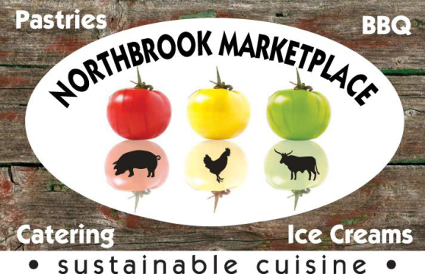
2 LITER SODA 2.99

Coke
Diet Coke
Sprite
Root Beer
Fresca

Includes Everything You Need In One Package! Disposable Chaffing Dishes, Serving Utensils, Plastic Ware, Plates, Napkins & Wet Naps.

NORTHBROOK
MARKETPLACE

CATERING PICNIC MENU

